Ideation Phase
Define the Problem Statements

Date | 15 FEB 2026
Team ID | LTVIP2026TMIDS47436
Project Name | Visualizing Housing Market Trends: An Analysis of Sale Prices and Features using Tableau
Maximum Marks | 2 Marks

Visualizing Housing Market Trends: An Analysis of Sale

Prices and Features using Tableau

The housing market is influenced by several factors, including location, property size, amenities, and economic conditions. Understanding these factors is crucial for homebuyers, investors, and real estate professionals to make informed decisions. However, traditional real estate reports and raw datasets are often complex and difficult to interpret.

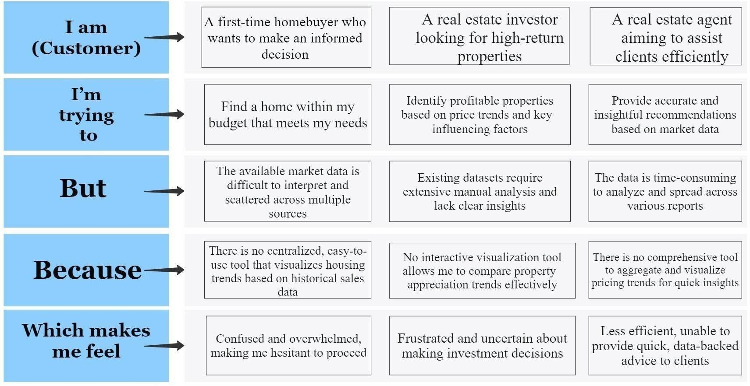
Problem Statement (PS) | I am (Customer) | I’m trying to | But | Because | Which makes me feel
PS-1 | A first-time homebuyer who wants to make an  informed decision | Find a  home within my budget that meets my needs | The available market data is difficult to  interpret and scattered across multiple sources | There is no centralized, easyto-use tool that visualizes housing trends based on  historical sales data | Confused and overwhelmed, making me hesitant to proceed

PS-2 | A real estate investor looking for high-return properties | Identify profitable properties based on price trends and key influencing factors | Existing datasets require extensive manual analysis and lack clear insights | No interactive visualization tool allows me to compare property appreciation trends effectively | Frustrated and  uncertain about making investment decisions
PS-3 | A real estate agent aiming to assist clients efficiently | Provide accurate and insightful recommend ations based on market data | The data is timeconsuming to analyze and spread across various reports | There is no comprehensive tool to aggregate and visualize pricing trends  for quick  insights | Less efficient, unable to provide quick, databacked advice to clients

